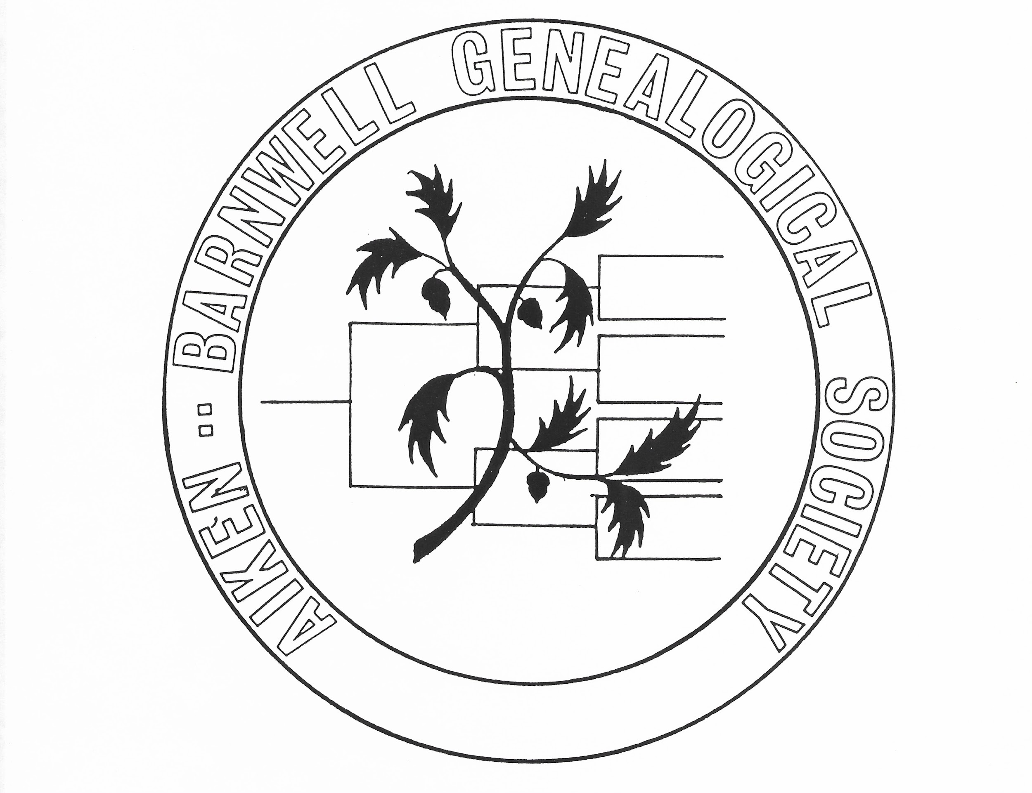

SC Genealogical Society
PO Box 24526
Columbia, SC 29224-4526

Dear Board and Members of the SC Genealogical Society:

You are cordially invited to the opening of “The Thompson Family of Salley, SC Historical Exhibit” on Saturday, February 1, 2020 from 3:00 PM-5:00 PM at the Aiken County Historical Museum located on 433 Newberry Street SW, Aiken, SC 29801.

The exhibit will feature the stories of enslaved relatives Milledge Thompson and Isaac Quattlebaum experiences during slavery; an enslaved relative Lavinia C. Thompson who served as a cook in the Confederate Army; and relatives Joshua and Queen T. Corley who experienced the pleasures and trials of sharecropping life in rural Aiken County. A brief history of Smyrna Missionary Baptist Church and connection to the Thompson Family will be featured as well.

A reception will include traditional food dishes from slavery, The Civil War, and post-Reconstruction periods which include family traditions. There will be a raffle giveaway as well.

For more information, contact Dr. Walter B. Curry, Jr., exhibit coordinator at (803) 404-2117 or email at renaissancegenpubllc@gmail.com.

We will be honored with your presence.

Cordially,

Pete Peters
President,
Aiken-Barnwell Genealogical Society

